Cone of Experience
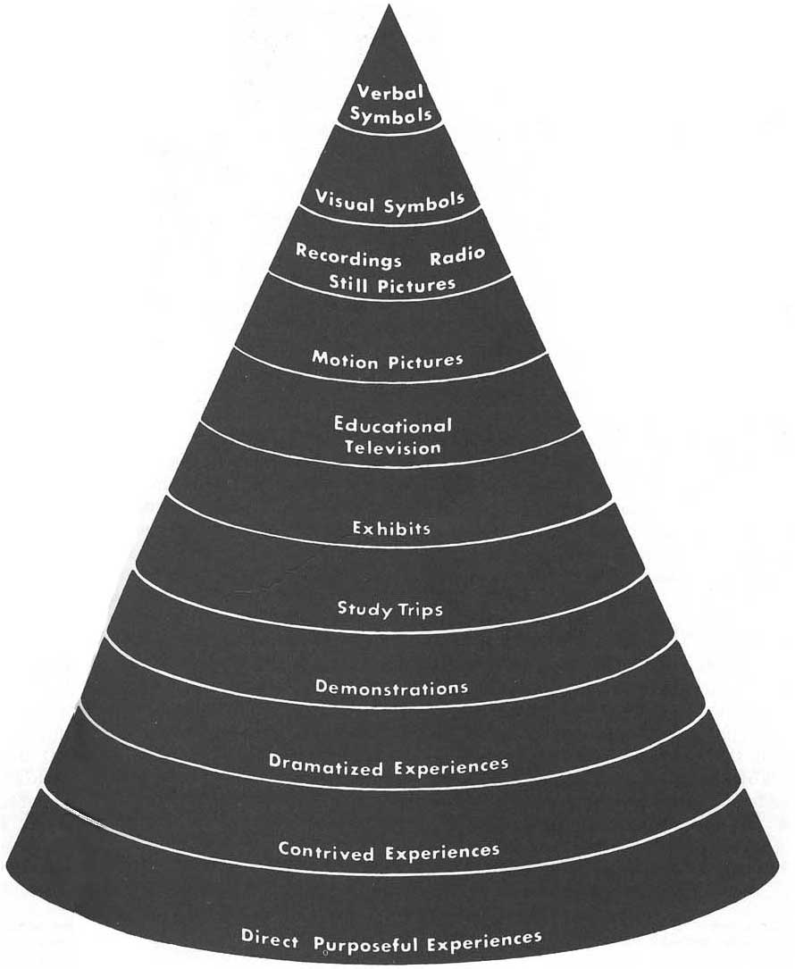Cone of Experience. Image borrowed from: http://qwertyrob.blogspot.com/... Click on the picture to follow the link.
Edward Dale's Cone of experience was first introduced in his book “Audio-visual methods in teaching” published in 1946. It is an image describing benefit of different types of learning experiences. The Cone was organized by starting with most abstract experiences from its top, changing to most concrete experiences at its bottom. In later editions of the book it was subjected to some minor changes, but the original cone image can be found here.
The importance of Dale's cone of experience is in its assumptions of how we learn more efficiently and in appliance of such resources or activities during the educational process. Assumptions stated in this cone have been of interest to many later psychologists and cognitivist theories.
NOTE: Bogus percentage numbers have later been added to Dale's cone. They aren't however in any way related to the original Cone. A collection of bogus cones often used can be found in presentation of Betrus and Januszewski.

Bibliography
Molenda, M. Cone of experience. Educational Technology: An Encyclopedia. 2003.
Development Modules: Selecting and Using Instructional Resources to Enhance Instruction - Section D.

